|  |  |
| --- | --- |
| Team ID | PNT2022TMID17521 |
| Project Name | Smart Solutions for Railways |
| Team Lead | Ragul R |
| Team Members | Prasanth S  Soundhar  Tamilmani |

Problem Statements:

Create a problem statement to understand your customer's point of view. The

Customer.Problem Statement template helps you focus on what matters to create experiences people

will love.A well-articulated customer problem statement allows you and your team to find the ideal

solution for the challenges your customers face. Throughout the process, you’ll also be able

to empathize with your customers, which helps you better understand how they perceive

your product or service.

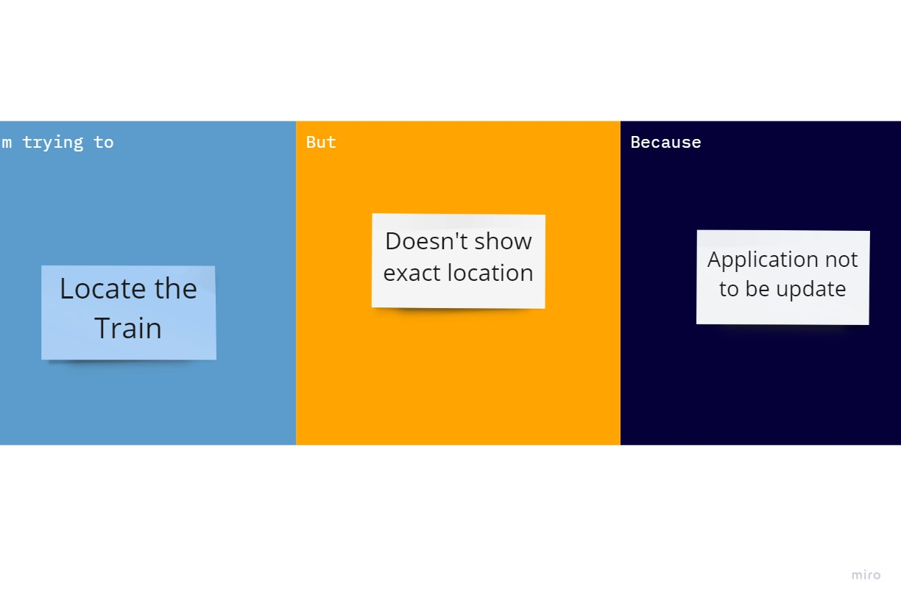

|  |  |  |  |  |  |
| --- | --- | --- | --- | --- | --- |
| Problem Statement(PS) | I am  (customer) | I’ trying to | But | Because | Which makes me feel |
| PS-1 | Passenger | Ticket booking | Website can slow | Multiple users | Bitter |
| PS-2 | TTR | Ticket checking | Website can  Update take some | Multiple users | Irritation |